

OS X 10.11 “El Capitan” Upgrade Walkthrough

# Objective

Upgrade a TE Connectivity Standardized Mac running OS X 10.9 “Mavericks” or OS X 10.10 “Yosemite” to OS X 10.11 “El Capitan”.

**Note: TEMPO 1.0 is designed to upgrade an already standardized Mac, and should not be used for new Mac setup.**

# Requirements

* Intel based Mac running OS X 10.9 “Mavericks” or newer
  + If you are running OS X 10.8 “Mountain Lion” or older, you may need to contact the Help Desk for additional assistance upgrading your Mac.
* Centrify installed and operational
* Local account with administrator rights
* **Wired connection** to TE Connectivity corporate network
* Known-good current backup (always a good idea before beginning this kind of upgrade)

# Summary

1. Verify Existing System
2. Download the TE Mac Prep Operation package
3. Install TEMPO
4. Complete the installation, supplying any requested information
5. Overview of changes
6. Install OS X 10.11 “El Capitan”
7. Troubleshooting and Fixes (if needed)

# Verify your system meets requirements

Verify that your system is running OS X 10.9 “Mavericks” or OS X 10.10 “Yosemite” by clicking on the Apple menu in the upper left corner of the screen and selecting the menu option “About this Mac”. A window will appear with your version number displayed in center of the main portion of the window.

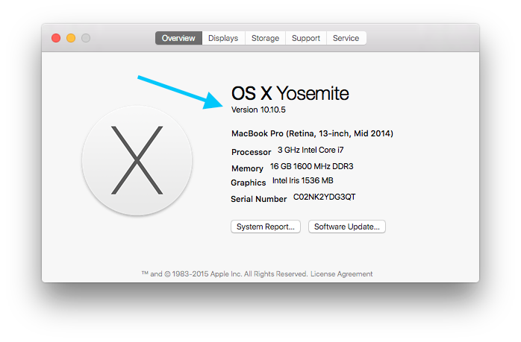

Connect your Mac to the TE Connectivity corporate network via an Ethernet cable. Verify that you can access internal corporate resources, such as the [myTE Homepage](https://portal.connect.te.com/sites/myTE/).

Verify that you have Centrify installed by clicking on the Apple menu in the upper left corner of the screen and selecting the menu option “System Preferences…”. A window will appear, there should a Centrify logo across the bottom row.

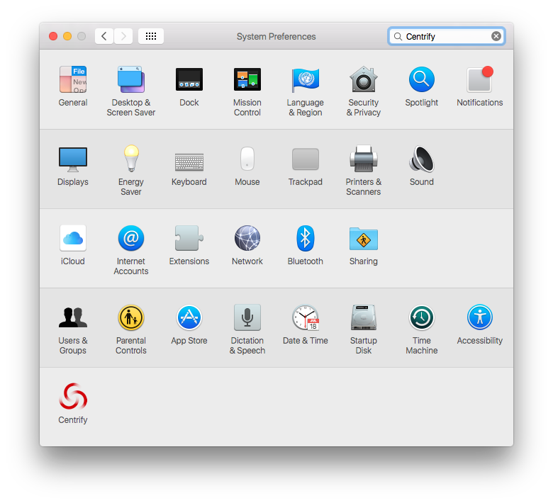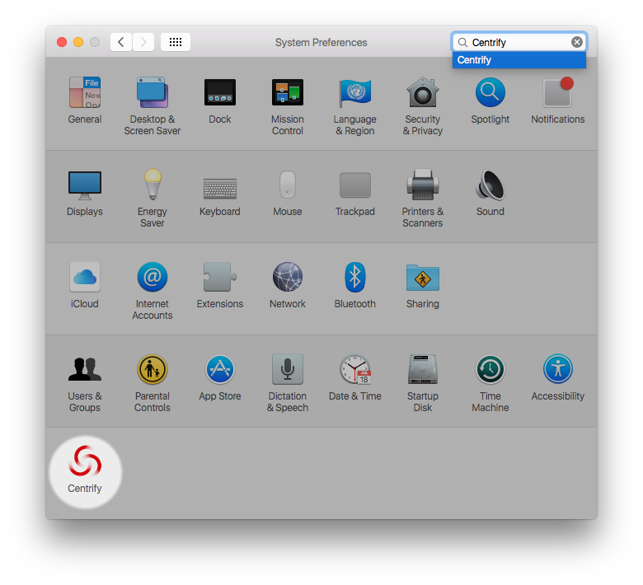

Clicking on that icon will bring up the Centrify Preference Pane. This may take some time to load, please be patient. On the right column of the upper section of the Welcome tab, confirm that the field labeled “CentrifyDC mode” is listed as “connected”. If this field instead lists “disconnected” verify that you can access internal corporate resources; if there is still no change, you may need to reboot your Mac while physically connected to the network.

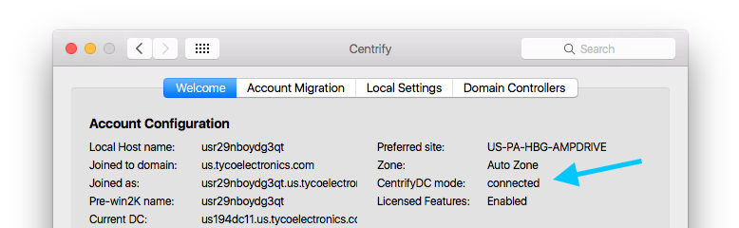

Verify that you have a *local* admin account by clicking on the Apple menu in the upper left corner of the screen and selecting the menu option “System Preferences…”. A window will appear, there should be a “Users & Groups” icon along the lower left side. Clicking on this icon will bring up the Users and Groups Preference Pane. Confirm that there is a user present in the list on the left with the label “admin” under their user name, but *not* labels such as “managed”, “mobile”, or “network” (you likely have multiple users listed here, and your AD account will likely have several such labels, just be sure there is an additional user that has only the “admin” label). This user is most likely named “localadmin”, but may have other names too; be sure you know the password to this user.

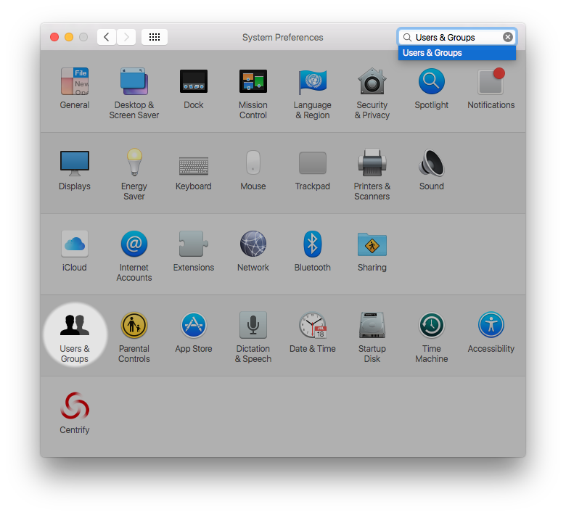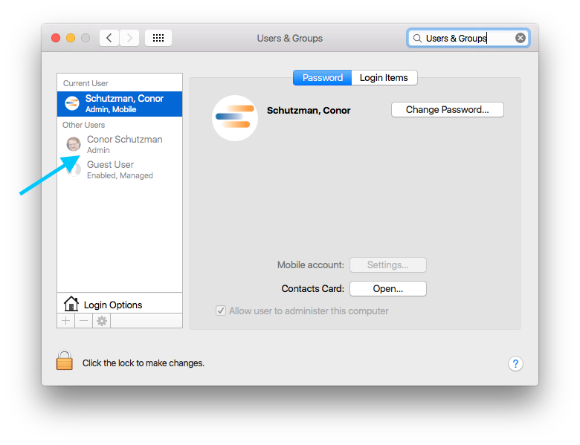

# Download the Mac Prep Operation package

While connected to the TE Connectivity corporate network, launch your preferred browser and navigate to the Apple Repository. Navigate to the TEIS folder, then the TEMPO subfolder, and download the latest version of the TEMPO package available.

As of the El Capitan release, the current version of TEMPO is version 1.0, and has the direct download link of:

<http://applerepository.tycoelectronics.com/TEIS/TEMPO/TEMPO-1.0>

# Install TEMPO

Locate the TEMPO package you recently downloaded, likely in your Downloads folder. Double-click to launch it. Depending on your settings, you may get a message that the package cannot be opened because it is from an unidentified developer; if this is the case, secondary click on the package icon and select “Open” from the contextual menu that appears.

You will be presented with a Welcome screen providing an overview of the minimum system requirements. Click “Continue” to proceed.

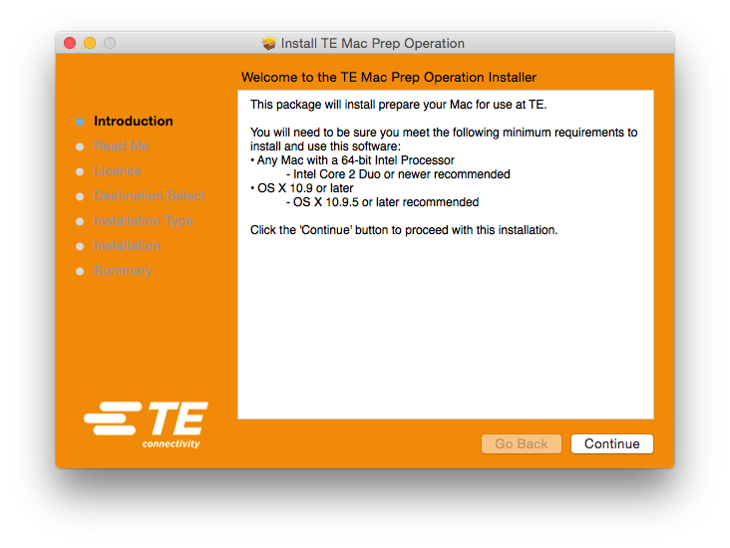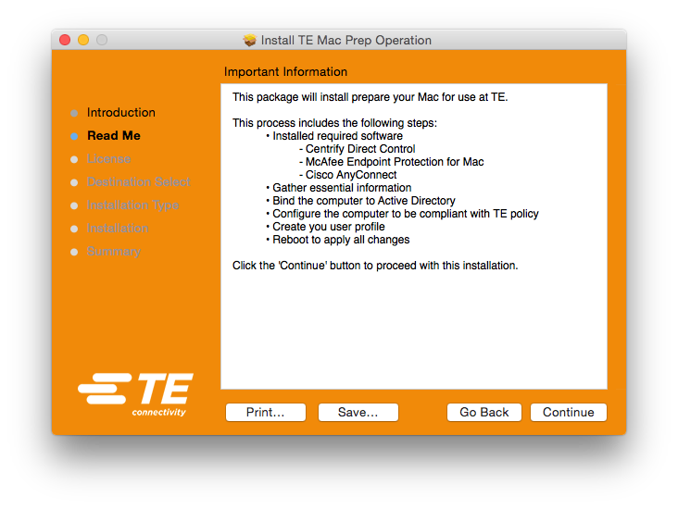

You will then be presented with an Important Information screen that lists an overview of the steps to follow. Click “Continue” to proceed.

Next you will be presented with a License Agreement. This is a basic license for the Unix binaries included in this installation. Once you have read through the agreement, click “Continue” to proceed. A sheet will drop down presenting you with an option to agree to the license, you will need to indicate this agreement by clicking on the “Agree” button to proceed.

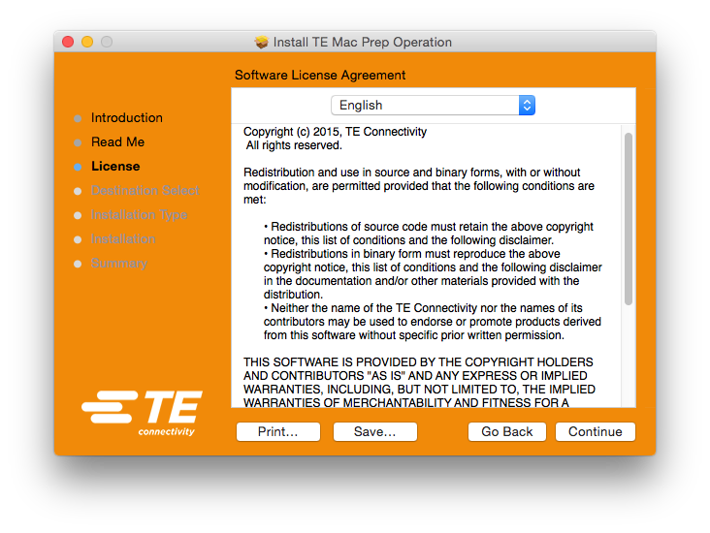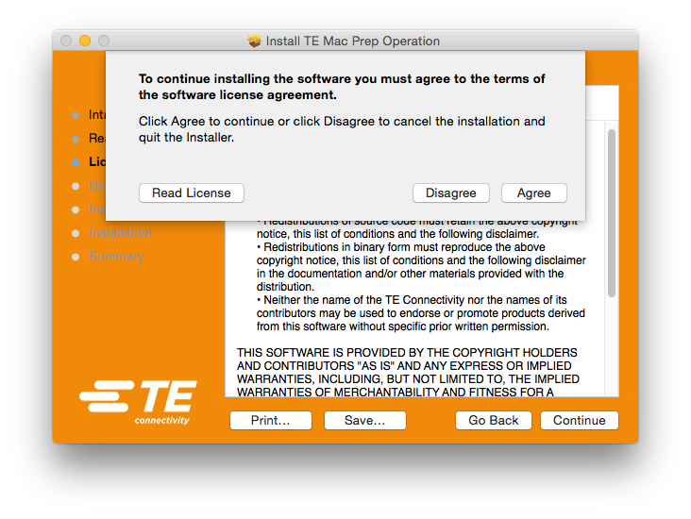

If you have multiple hard drives, or partitions, you will then be presented with a screen to select the destination drive. Select the drive you normally use as a boot device, and click “Continue” to proceed.

Once you have selected your installation volume, or if you only have one hard drive, you will be presented with a summary of space required to complete the installation. Click the “Install” button to begin the installation.

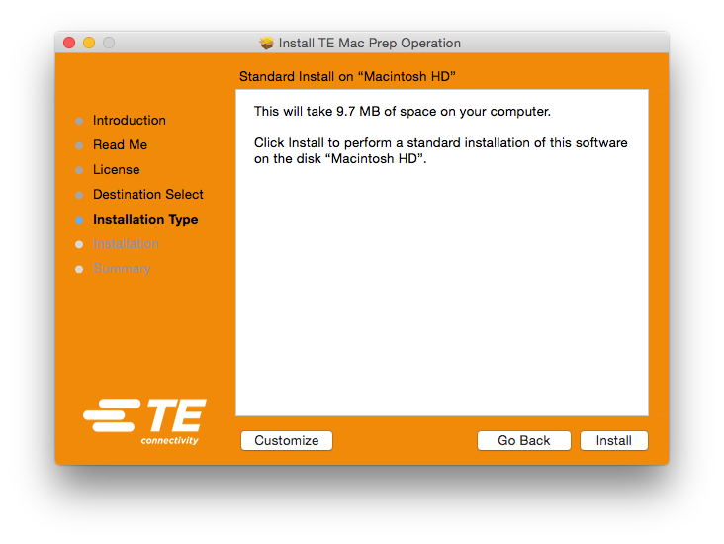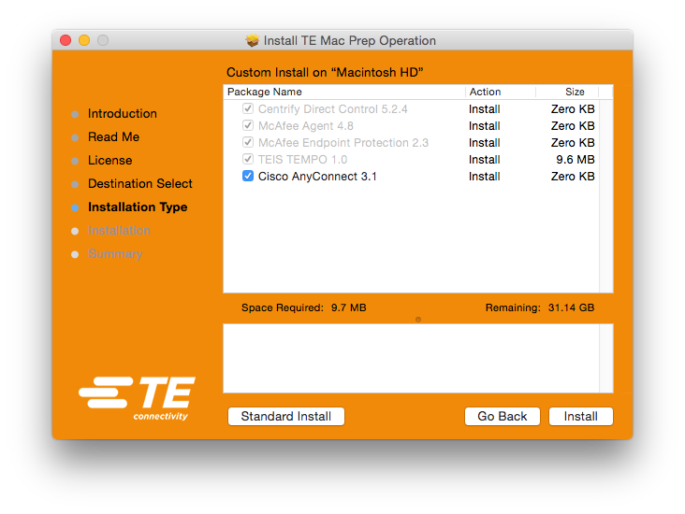

Alternatively, you can press the “Customize” button to add or remove optional installation settings.

You will be then be prompted for admin credentials. These credentials can be for any admin user, either your AD user (assuming you have prompted that user to be an admin) or the local admin user (as described above).

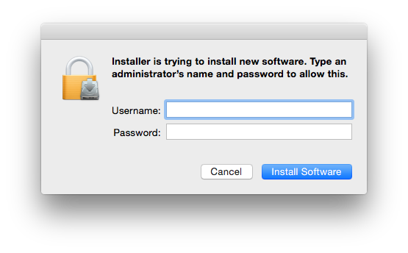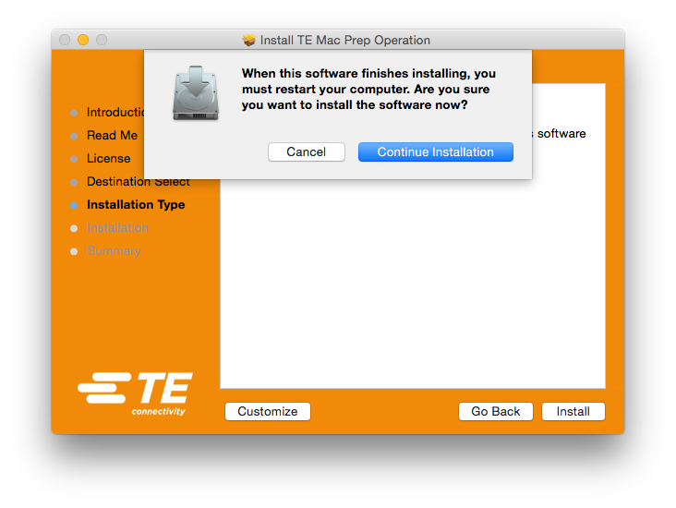

Lastly, you will be informed that this installation will require a reboot once completed. If your current activities are not conducive to performing a reboot, you can click “Cancel” to abort the installation so that you can begin again at a later time. Click “Continue Installation” to begin the installation.

# Complete the TEMPO installation

Once the installation begins, you will be presented with a dialog box that provides some additional information about the rest of the process. While the progress bar and text inside the Installer window may not accurately reflect the installation activity, you will be notified of each step through the use of OS X Notification windows which should appear in the upper right throughout the installation.

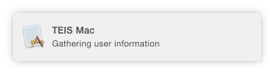

While total installation time will vary based on the specifications of your Mac and your network bandwidth, this installation will likely take 7 to 10 minutes for most users. The installation may appear to stall at various points while it performs tasks in the background, as long as the installation window is open it is still working, your patience is appreciated.

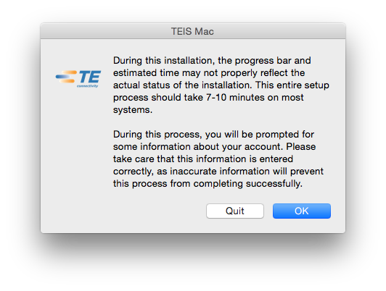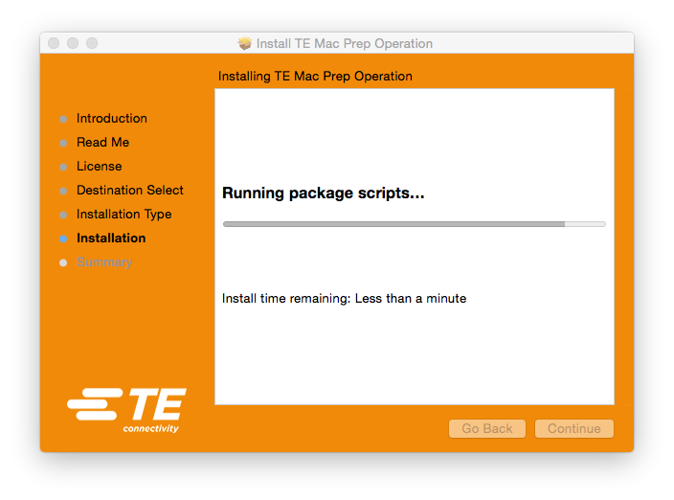

The installer will then process through several component installations, including Centrify, MacAfee Agent, and McAfee Endpoint Protection for Mac.

You will then be prompted to enter your User ID. This is your eight-digit network ID, typically formatted with 2 letters followed by 6 numbers. Please be sure the letters are lowercase, and you will not need to enter any kind of domain qualifier. This prompt is then repeated, and the two entries compared to each other in an effort to avoid typos. If these two entries do not match, or if you accidently leave the default text in place, you will be asked to repeat the process. It is essential that this information be accurate, as it is what is used to create your network account at the end of this process, an incorrect User ID being used for this process may leave you unable to log in to your AD account on this Mac.

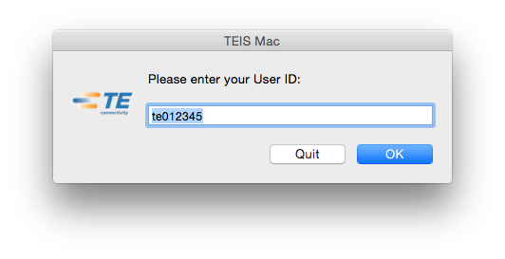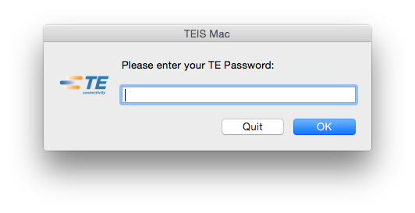

After your User ID is confirmed, you will then be prompted to enter your password. Like the User ID, you will be prompted twice to make sure it was entered correctly, and will result in similar issues if entered incorrectly.

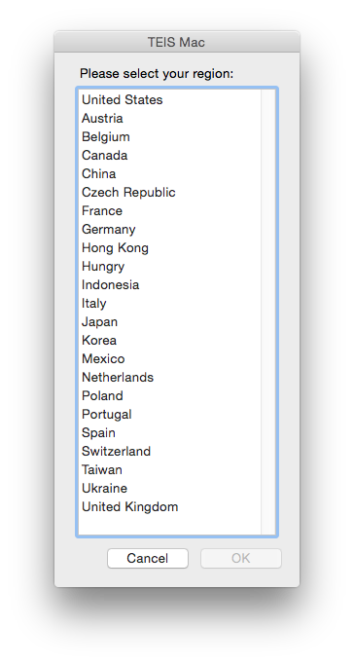With your credentials entered, you will be prompted to select your region from a list. This selection is used to determine which domain controller your Mac will be bound to. This is also used to build your computer name (aka “hostname”). If your regional domain server isn’t in this list, please contact the Help Desk for further assistance.

You will then be prompted to enter your building number; this is typically a three-digit identifier.

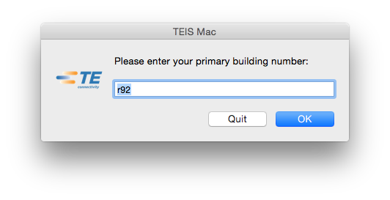

The installation will continue. The following steps will be performed, but require no direct interaction from you:

* System time will be set to the corporate time server, and updated to make sure the current time is correct.
* Any existing AD bind configuration will be removed.
* The computer will be bound to the domain controller specified above.
* The corporate Certificate Authority will be installed.
* The AD Group Policy, for the Mac, will be pulled applied.
* Preferences will be set so that you won’t be nagged with various additional setup screens (such as the screen that informs you about “natural scroll direction”).
* The user account will be created using the credentials entered above. See below for more about this account.
* The user account, if not already an admin, is prompted to have admin rights.
* Permissions on the user’s home folder are verified, and if needed, repaired.
* Single Sign On preferences are set
* Shortcuts (also known as “Aliases” or “SimLinks”) are created for some diagnostic utilities.
* Several Unix system folders are examined to make sure they are not visible from within Finder.
* System settings are set to a standardized configuration.
* Proxy is set for all active network interfaces.
* Login window background is changed in indicated this is a TE Connectivity system.

All actions taken by the installer are logged, with all logs accessible within the Console utility.

Once all of these actions have completed, you will be presented with a success message. In order to proceed, you will be required to restart your Mac.

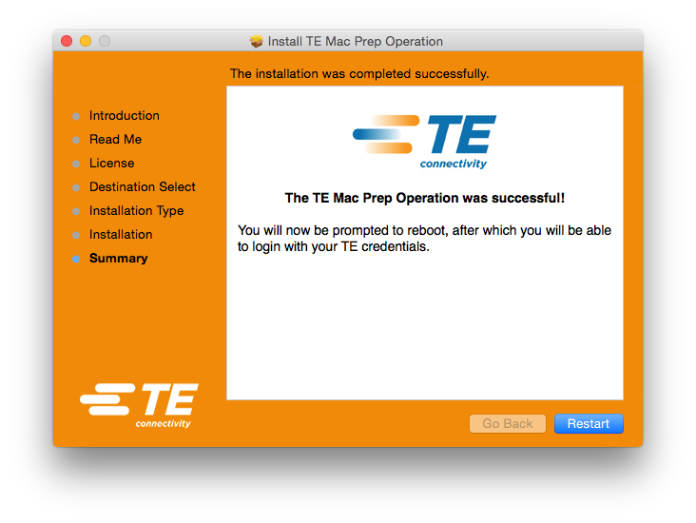

# Your new standardized Mac environment

Even before installing El Capitan, you will likely notice some changes that TEMPO has applied. Likely most obvious is that your login window background will have changed from the default Yosemite image to flat gray image with a TE logo in the lower right.

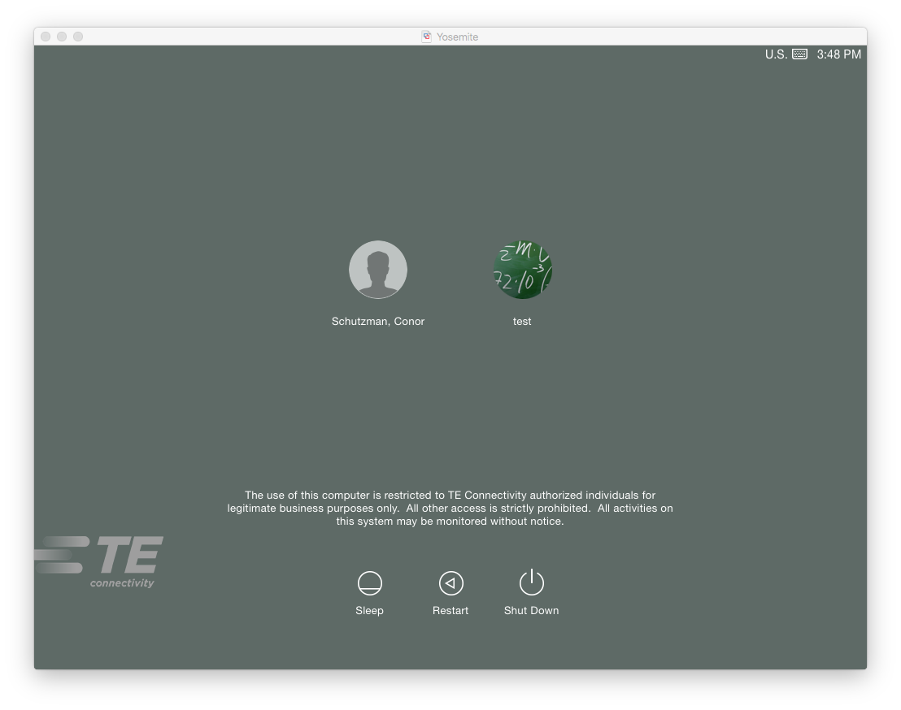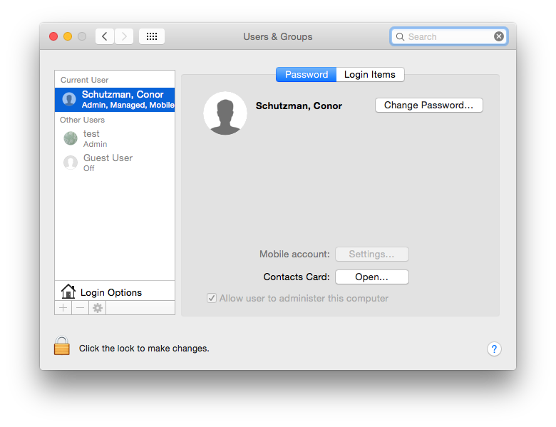

You may also notice that the user options are presented as icons, instead of fields to type your credentials. This is because your user is now a “mobile” user instead of a “network” user. This kind of user is still synced with AD, so in many ways it will behave just like your account always has (including being able to change your directory password directly from the Users & Groups pane of System Preferences); but your Mac will also treat this account like a local account in many ways, including allowing the account to unlock your Mac should File Vault be enabled in the future.

# Installing El Capitan

Official upgrade instructions can be found on [Apple’s OS X Support Site](http://www.apple.com/support/osx/upgrade/)

Once released, the OS X 10.11 “El Capitan” installer will be available from the Mac App Store. You can access this by clicking on the Apple menu in the upper left corner of the screen and selecting the menu option “App Store”. This download may take an extended time period, as it is approximately 6 GB in size. Once the download is complete, there will be an “Install OS X El Capitan” icon in your Applications folder. Double click on this icon to begin the installation.

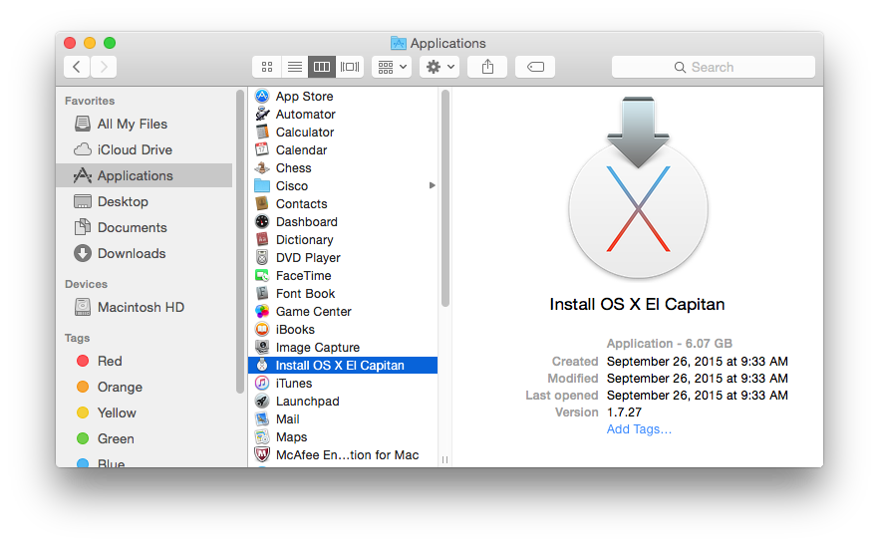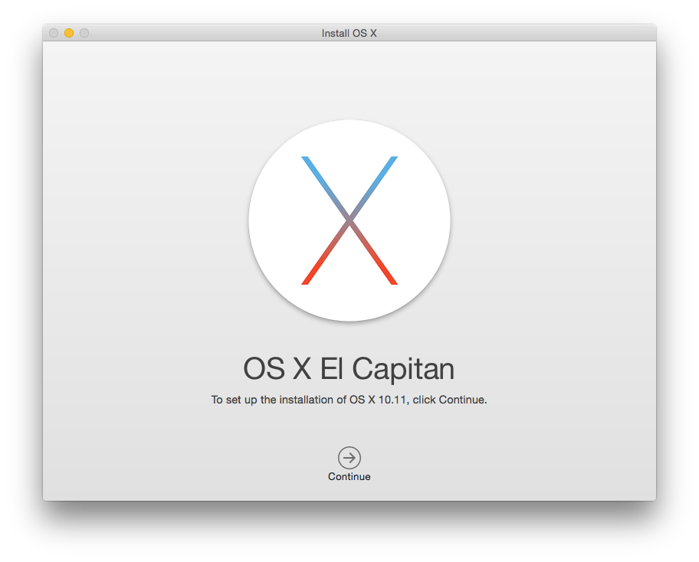

After clicking “Continue” on the main installer screen, you will then be presented with the OS X 10.11 “El Capitan” license agreement. Once you click “Continue” on the license agreement screen, sheet will drop down presenting you with an option to agree to the license, you will need to indicate this agreement by clicking on the “Agree” button to proceed.

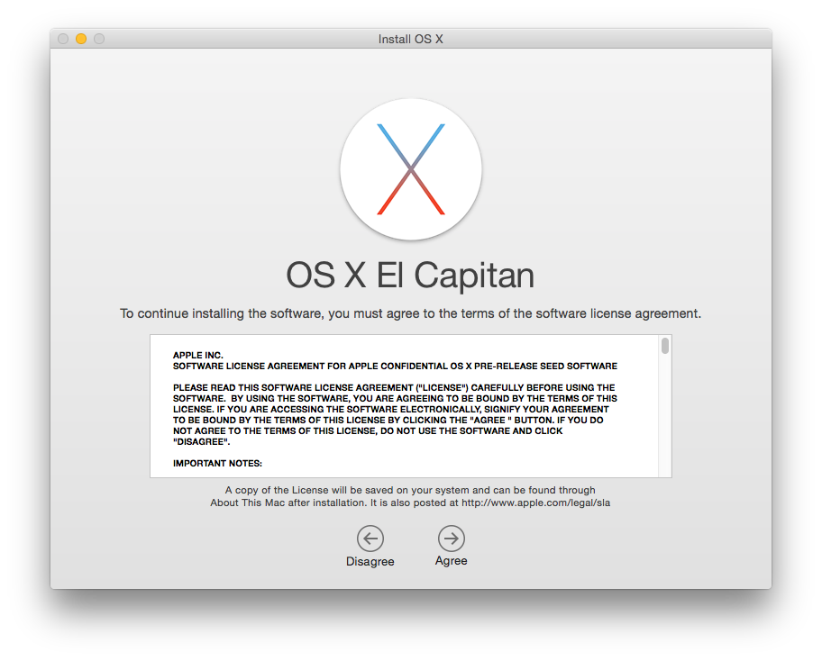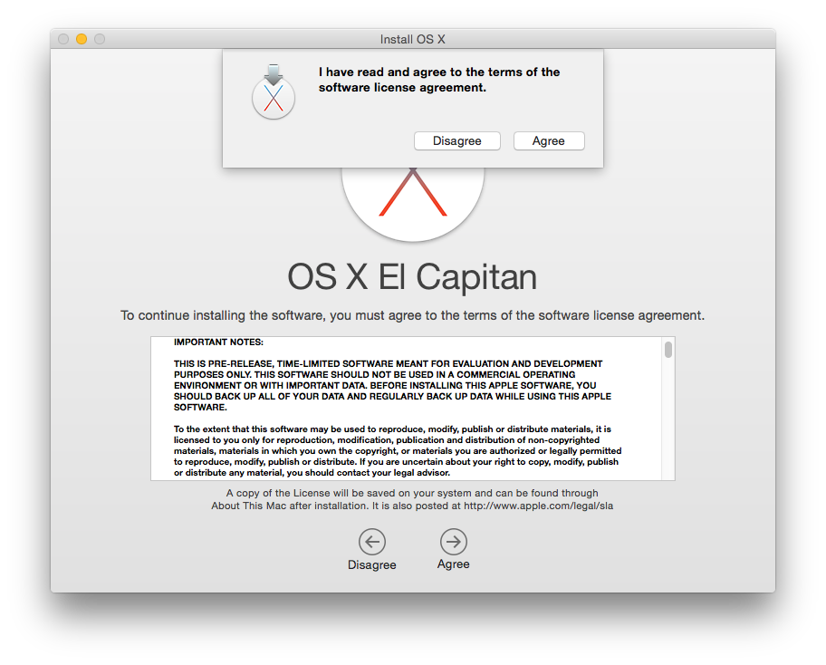

If you have multiple hard drives, or partitions, you will then be presented with a screen to select the destination drive. Select the drive you have OS X installed on, and click “Continue” to proceed.

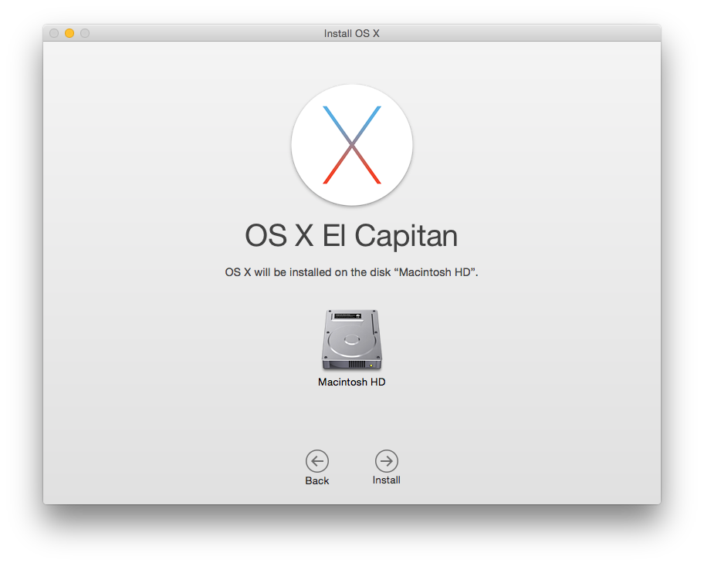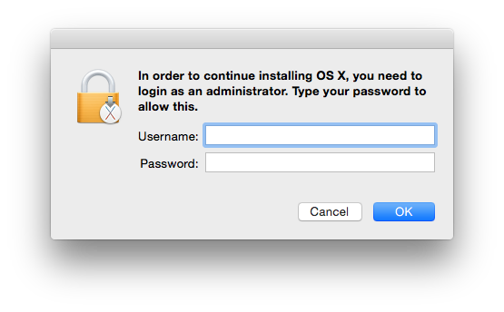

You will be then be prompted for admin credentials. These credentials can be for any admin user, either your AD user (assuming you have prompted that user to be an admin) or the local admin user (as described above).

The installer will then begin to prepare the installation. On most systems, this usually takes 3 to 5 minutes. Once this preparation completes, you will be prompted to reboot your Mac.

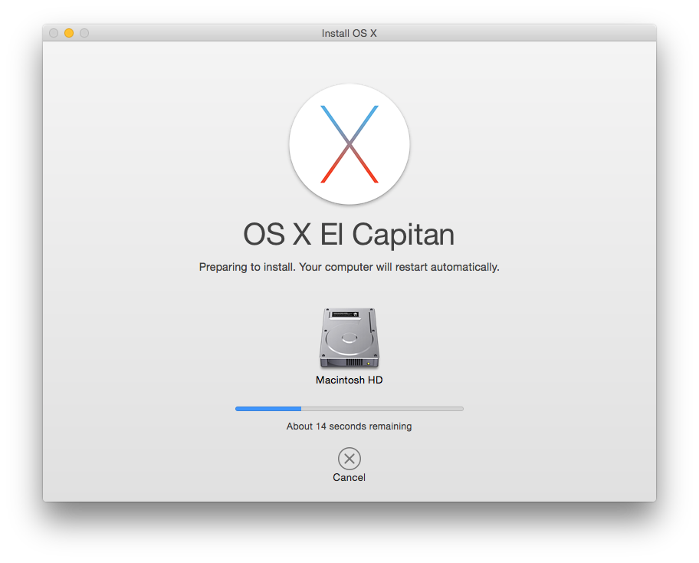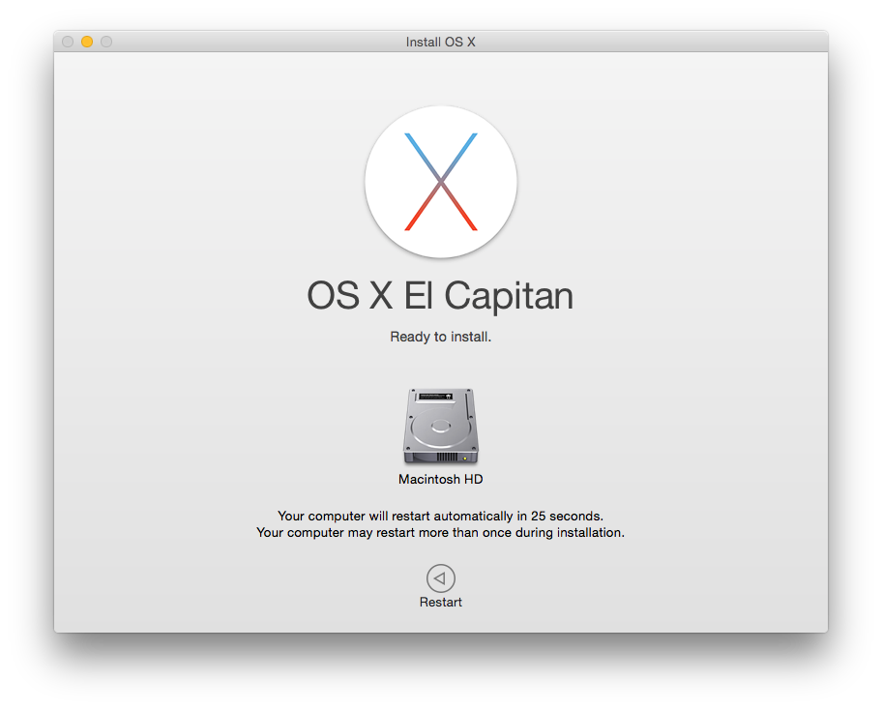

After the reboot, the rest of the installation will take place in a special boot environment, there will be no desktop, and you will not have access to the Mac during this installation time.

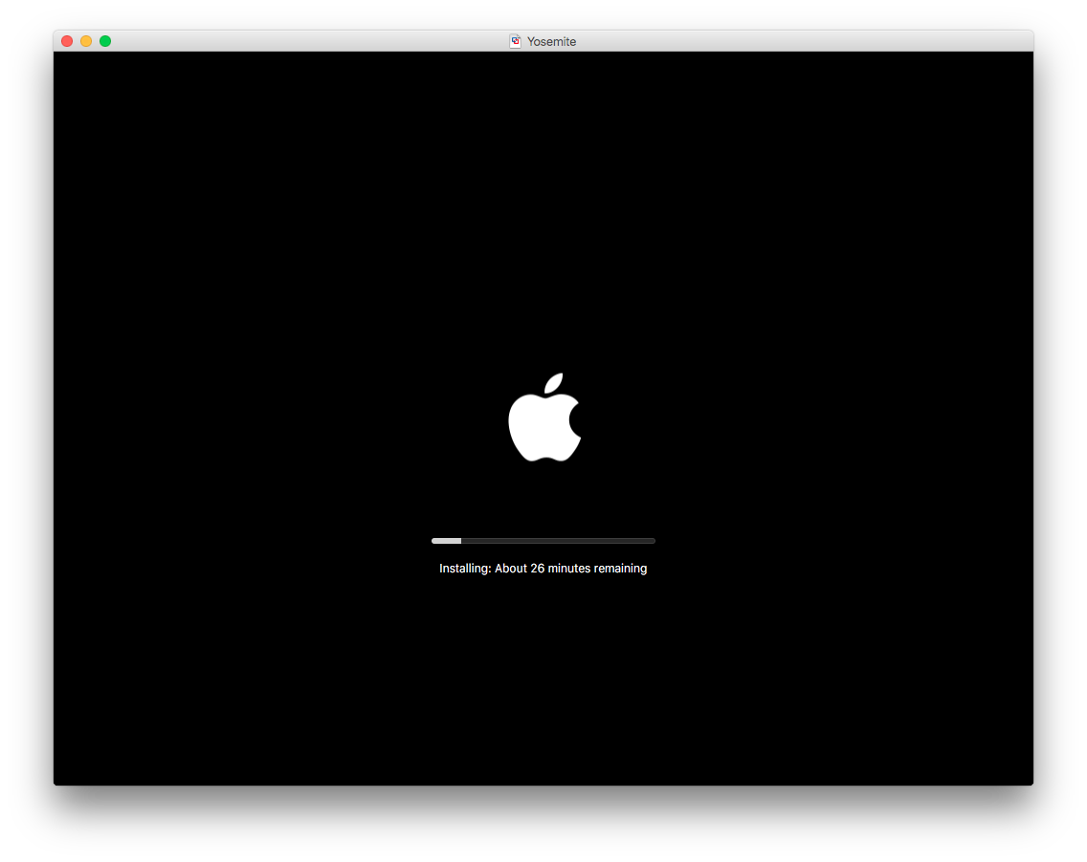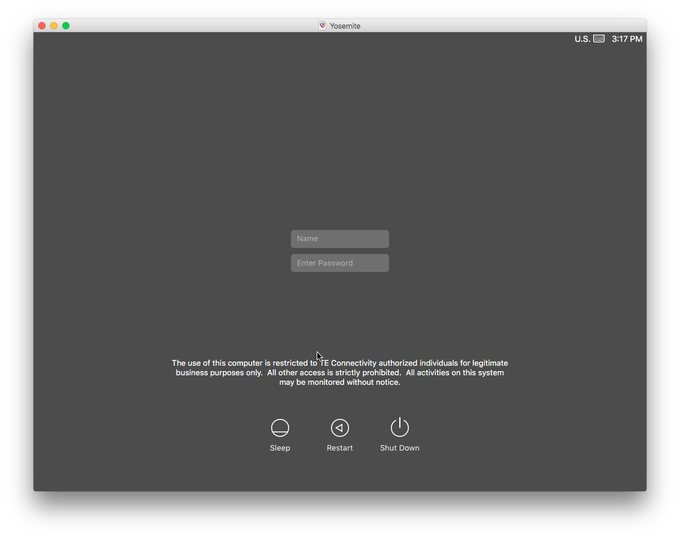

Once the installation completes, you will be presented with what looks like a login window, but with the old credential fields. While this looks similar to a login window, this is actually an unlock screen, similar to those displayed when waking the Mac from sleep or exiting a screen saver. The credentials required here are the credentials for the user you were logged in as when starting the OS X 10.11 “El Capitan” installer.

Once you enter your credentials, you will be back at your desktop, ready to use OS X 10.11 “El Capitan”.

# What to do if something goes wrong

If you do not install TEMPO, or at least upgrade Centrify prior to upgrading to OS X 10.11 “El Capitan”, you may be faced with being unable to log in to the Mac with your AD account. If this happens, you will need to log in with the local admin user (as outlined above).

Under some circumstances, even the local user will not be fully functional. You can test this by launching System Preferences by clicking on the Apple menu in the upper left corner of the screen and selecting the menu option “System Preferences…”. Open one of the preference panes that require authentication to unlock, such as the Network pane or the Users & Groups pane. Click on the lock icon in the lower left hand corner, and enter your local admin credentials. If the lock opens, then your local user is fully functional, if you cannot unlock the preference pane, then you will need to take additional steps to repair your installation.

If your local user is fully functional, you should be able to download and install TEMPO (as outlined above). After which, you should be able to login with your AD account, and your previous home folder should be intact.

If your local user is not able to authenticate, you will need to install TEMPO through Terminal. To simplify this for you, a script has been created, downloadable from the [Apple Repository](http://applerepository.tycoelectronics.com/Upgrade-to-ElCapitan/Repair%20Install.zip). Download the zip file, and your browser should automatically extract it; make sure the resulting file is in the same location as the TEMPO package file, and double click on the Repair Install script. Terminal will launch, begin the install, and prompt you for your local admin password (which should work in Terminal). While you won’t see all of the installer interface, you should still see the prompts for your account information, and the installation will progress much as outlined above. When the install completes, Terminal should quit, you will then need to reboot your Mac.

If this does not resolve the issue, you may need to contact the Help Desk for additional assistance.